Manual for GraphIAST

Open the software:

1. First both pure component adsorption isotherms must be uploaded with the “Upload File” button. The data will be automatically plotted in the figures on the left side.
2. Next, the data must be fitted in order to later calculate the selectivity by IAST. For this, there is a list of different models for the fit. The “Interpolator” function solves the fit numerically1, while the other are thermodynamic models for adsorption processes.
3. The fit is calculated and plotted by the “Fit Isotherm” buttons. Both isotherms can be fitted separately with different models, if so desired.
4. If the automated fit doesn’t work or if you’d like to have certain fit parameters to start with, it is possible to define the starting fit parameters manually by the “Custom Fit” buttons.
5. A new window will open in which you can enter the values of your choice. Not every field has to be filled-in, but for the model you choose all parameters have to be given. The values can be changed afterwards.
6. The “Clear” button deletes the custom defined parameters in order to use again the automated default guesses.
7. The final fitting parameters as well as the RMSE (root mean squared error) are displayed in the Fitting Parameters textbox on the left side under the plots, so that the fit can be evaluated. A new fit doesn’t overwrite the output, so that fits can be compared with each other by scrolling through the output log.
8. The button “Logarithmic Axis” can change the x-axis of the graphs from linear to logarithmic and back.
9. For IAST calculations, the pressures and mole fractions of gas 1, at which the selectivity should be calculated, have to be pre-defined. Therefore, you can enter all the values you want to use in these entry fields and separate them by commas. The pressure must not exceed the maximum pressure of your single adsorption experiments and the mole fractions have to be greater than zero and smaller than one.
10. The selectivity of gas 1 over gas 2 can be calculated using IAST. All pre-defined (step 9) pressures and mole fractions will be used to calculate the selectivity at different pressures and gas compositions.
11. The figure will show the selectivities at the pre-defined pressures for the first mole fraction that was entered before to show that the calculation was successful.
12. The calculated selectivities can be stored together with their respective mole fractions and pressures in one file for further data processing (csv or txt; comma-separated).
13. The software can be closed with the “Quit” button.
14. A Help button is in the bottom right corner to explain the steps with keywords while operating the software.

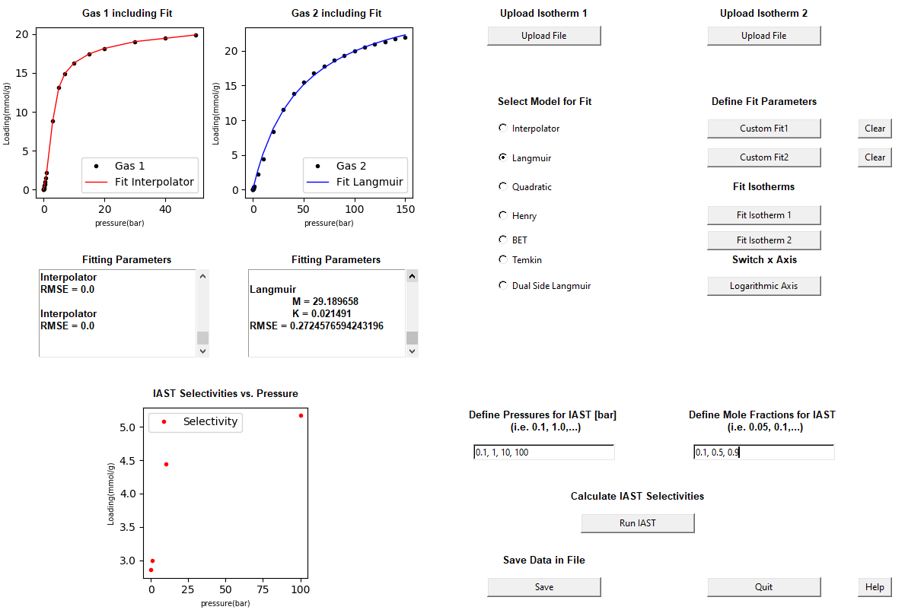

**1**

**2**

**3**

**4**

**6**

**8**

**7**

**9**

**10**

**11**

**12**

**13**

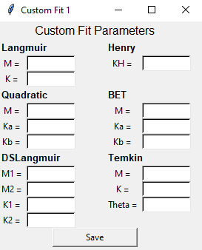

**7**

1 C. M. Simon, B. Smit and M. Haranczyk, *Comput. Phys. Commun.*, 2016, **200**, 364–380.